Life at Lucas Properties
Fall Edition - 2016


“In The Spotlight”

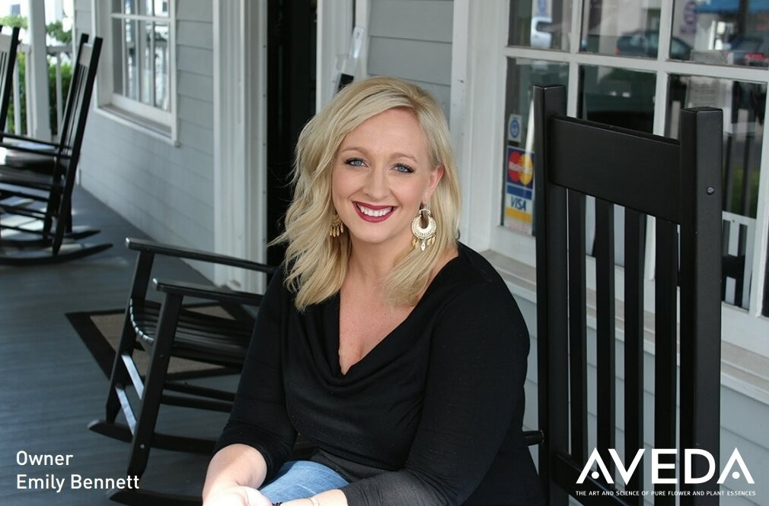

MOVING ON UP!
A New Horizon Aveda Salon has been a fixture at 507 Ocean Boulevard for years. Clients come to see Emily for all of their beauty needs AND her smiling face.

This time it is the salon itself making a change. A New Horizon Aveda Salon is now located on the 2nd floor in Suite 203. Emily has created the same warm and friendly environment that her clients are used to in her new upstairs salon.

The downstairs space (Suite 101) is now occupied by St. Simons Island’s newest retail shop Saltwater Cottage. Owners Debbie and Scott Estes are offering beach themed and inspirational home accessories and gifts.

When Emily is not beautifying St. Simons Island one client at a time, she enjoys spending time with her husband and her daughter.

To make an appointment call Emily at 634-0227.

Welcome New Lucas Properties Tenants
301 Sea Island Road
Larry Thompson – Suite 5
Virtual Leases
Lifestyle Sandbox, LLC
Abundance Financial
Deborah L. Britt, Attorney
William Ligon
CN Global Partners
5500 Frederica Road
Geneva Advisors – Suite 1217
Sol Financial Advisors – Suite 1220
Cocktails & Details – Suite 1221
PC By The Sea – Suite 2101
1620 Frederica Road
Misty’s Element Massage – Suite 203
507 Ocean Boulevard
Saltwater Cottage – Suite 101
________________________________

Available Lucas Properties
5500 Frederica Road
“Build to Suit” Spaces
1st Floor - 981.5 sq. ft. to 1,963 sq. ft.
and
2nd Floor – 7 Executive Suites Available
Ranging in Size from 126 to 190 sq. ft.

507 Ocean Boulevard
Suite 204
2nd Floor, 247 sq. ft., Reception Area
and
2nd Floor – 7 Executive Suites Available in December 2016
Ranging in Size from 69 to 219 sq. ft.
Please Contact Us for More Information
912-634-9877 lhooper@lucasprop.com or admin@lucasprop.com

Art’s Reflections

“The Presidential Election”
By Art Lucas

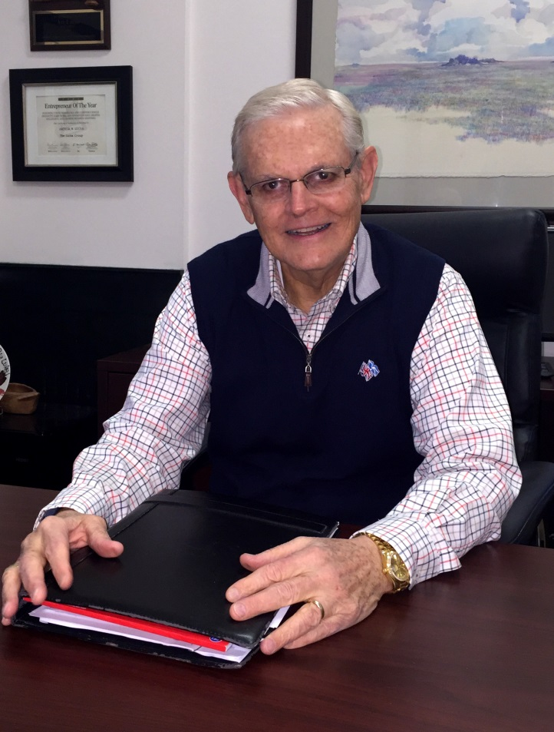

The airways, social media and conversational chatter are thick concerning our upcoming Presidential election. November 8, 2016 will mark the United States 58th Presidential election, which all began in 1789 by electing George Washington. Washington, who started the process, was an independent and not a member of any organized political party.
Since 1789 to present day (every 4 years) the United States has held an election for President and Vice President. Through stormy weather, depression and wars (even our Civil War) we have never missed an election. That is an amazing record for any country.

I hope all of you have or will vote. This is a civic responsibility that is the foundation of our great democracy. Winston Churchill once said “America, after trying everything else out, usually gets it right” and I believe that about our democracy.



The 5500 Frederica Family is Growing
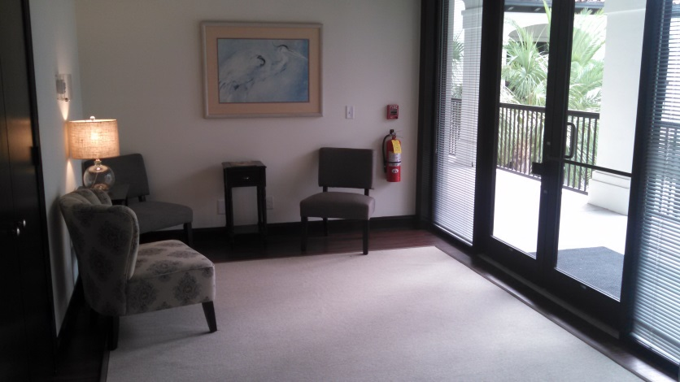
This summer we added Ten Brand New Executive Suites on the Second Floor of the West Wing at 5500 Frederica Road.

We have three new tenants all moved in and open for business and we are excited to see who will be their next new neighbors! Call us for leasing information at 634-9877!

Murray Nellis Law Group expanded their existing space next door to add three new offices making way for the addition of Abiding Love Adoption Agency. Congratulations to Gil and Carrie on their success!

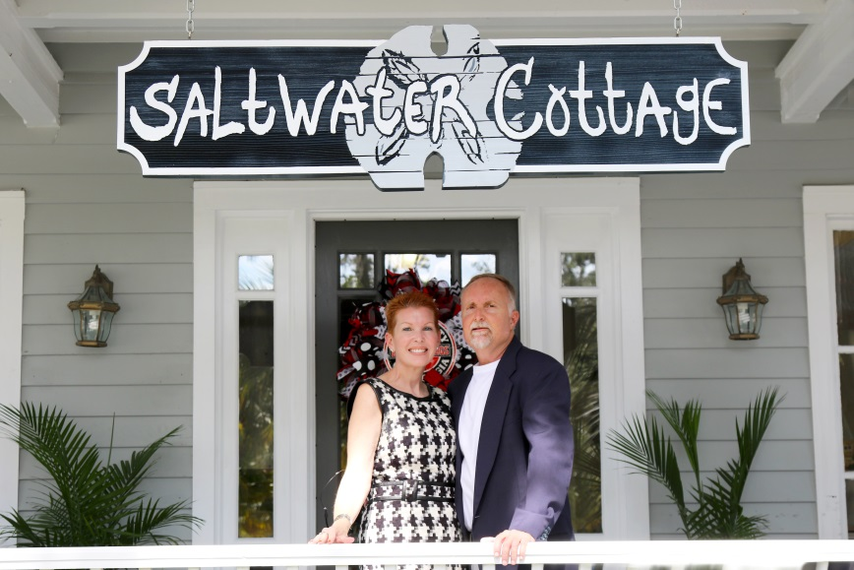
Lucas Properties Welcomes
Saltwater Cottage to 507 Ocean Boulevard
October 1st marked the official Grand Opening of Saltwater Cottage owned and operated by Scott and Debbie Estes (formerly of Titusville, FL). Saltwater Cottage is offering inspirational and beach themed gifts, books and decorative furnishings that are perfect for any coastal home. Please make sure you stop in and say hello!

Lucas Properties


We Are Once Again a
Proud Sponsor of the
2016 RSM Golf Classic PGA Tour Event
November 14 – 20, 2016
At The Sea Island Golf Club and
Hosted by Davis Love, III

Lucas Properties
Our Pledge

Lucas Properties strives to be your premier office leasing firm. We take pride in offering the best office leasing services in the Golden Isles.

Save The Date

Mark Your Calendars for Wednesday, December 7th! We will be hosting our annual Holiday Luncheon exclusively for the Tenants of Lucas Properties. Sending more details soon!

If you have any questions or concerns, please do not hesitate to contact us. We are available to you at 301 Sea Island Road, Suite 6, or you may reach us at 912-634-9877 during regular office hours. For emergencies after hours, please contact us at
912-996-0326 or admin@lucasprop.com. Web site: www.lucasprop.com

Lucas Properties - Conference Rooms

When you are meeting with clients, it is nice to have the option of using our conference areas in addition to your office space.

As tenants of Lucas Properties, you are able to reserve a conference room for a small fee. You can use any of the 5 rooms available at our 3 properties.

We also offer our conference rooms to guests who are not tenants. This is a great option for anyone looking for a space to meet with clients or visitors.

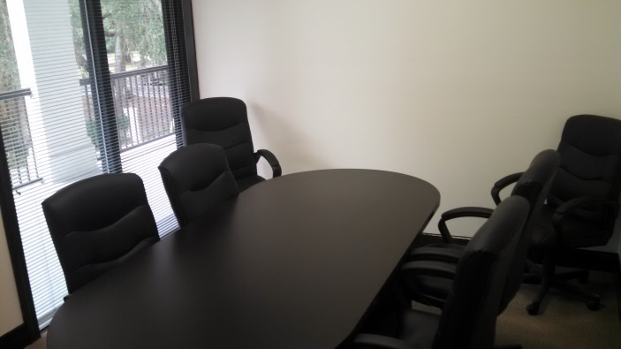
5500 Frederica Road

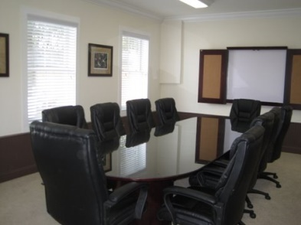
507 Ocean Boulevard

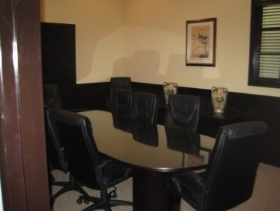
301 SEA ISLAND ROAD

Conference Room Rental Rates
507 Ocean Blvd. $40 tenant / $70 guest
301 Sea Island Rd. Small: $30 tenant / $50 guest
301 Sea Island Rd. Large: $40 tenant / $70 guest
5500 Frederica Rd. Both: $40 tenant / $70 guest

