***Life at Lucas Properties***

***March - 2017***



**“In The Spotlight”**

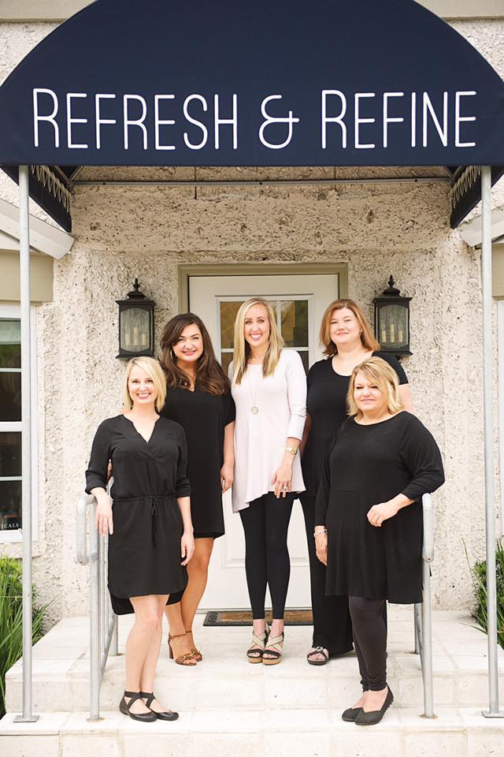

**Refresh & Refine, at 1620 Frederica Rd., is a Medical Spa & Boutique offering both spa services and aesthetic skin rejuvenation treatments designed to help you look and feel your best.  The boutique features skincare products, make-up, jewelry, gifts and accessories.**

**Johnson Medical & Aesthetics, owned by Dr. Kelly Johnson and his wife, Mandi Johnson, provides medical and aesthetic services including Botox, dermal fillers, Kybella, and vitamin injections.**

**Also on site are Jennifer Owens Skin Care and Lea Downie Massage.  Jennifer Owens, Aesthetician, offers an array of aesthetic services and custom skin care. Lea Downie, LMT, specializes in Swedish, deep tissue and hot stone massage.**

**Welcome New Lucas Properties Tenants**

**5500 Frederica Road**

Atlantic SE Limousine

getAbstract, Inc.

Deep Field, Inc.

The Loft

**1620 Frederica Road**

Refresh & Refine (Expanding)–Suite 200

**301 Sea Island Road**

Fred Kopp, Attorney at Law-Virtual

Slightly OCD Cleaning-Virtual

**507 Ocean Boulevard**

Lifestyle Sandbox, LLC–Suites 218 & 219

Nibble Nation–Suite 214

Jim Kaminer–Suite 213

Healing Waters Wellness and Massage–

Suite 216

Emmons Realty (Expanding)-Suite 215

Island Bicycle – Suite 101

[](https://www.google.com/imgres?imgurl=http://www.clipartkid.com/images/384/this-entry-was-posted-in-blog-bookmark-the-permalink-zFDDI7-clipart.png&imgrefurl=http://www.clipartkid.com/religious-thanks-cliparts/&docid=EmoNpte_dPi9iM&tbnid=G805umo8AppL0M:&vet=1&w=565&h=586&bih=596&biw=1152&q=many%20thanks%20clipart&ved=0ahUKEwjkzvCgv8zRAhUTziYKHTmDBQgQMwiDASgsMCw&iact=mrc&uact=8)

Many thanks for making the 2016 **Lucas** Properties Holiday Luncheon such a fun event. We enjoyed being able to visit with you and express our appreciation for your business throughout the year!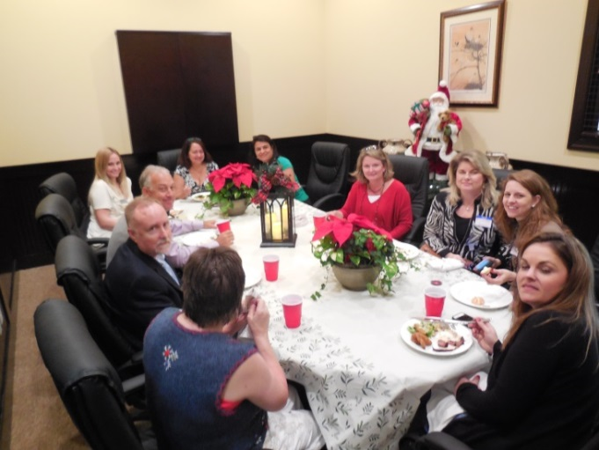

**Art’s Reflections**

**“Entrepreneurs – People of Action”**

**By Art Lucas**

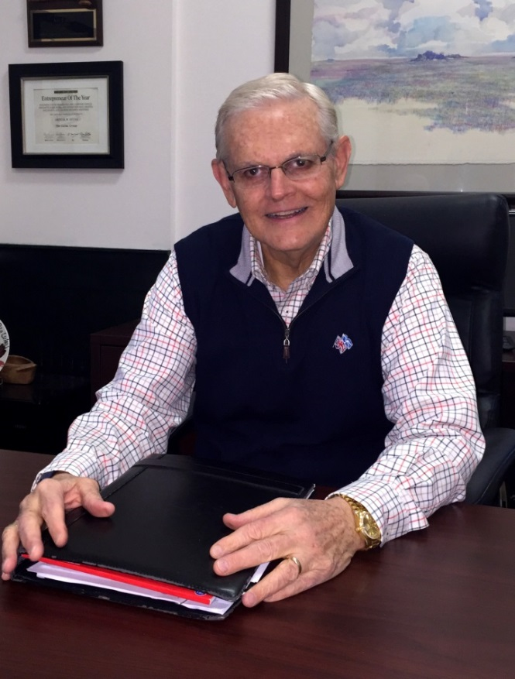

**Lucas** Properties has a number of entrepreneurs who have leased space in one of our offices. It has been exciting to watch them grow. Two that come to mind are Mandi Johnson and her team from Refresh & Refine at 1620 Frederica Road (who is being featured in this newsletter) and Roberts Civil Engineering who started with us at 301 Sea Island Rd. in 2012. Johnathan Roberts has now grown his firm to 9 associates. Both of these entrepreneurs and others in our four buildings fit the classic characteristics of successful start-up owners.

Entrepreneurs are upbeat, positive, highly motivated individuals. They are always thinking of ways to improve their business and are willing to risk resources and energy to do so. They are creative doers, someone who is proactive. They also have a decisiveness bent and don’t tolerate procrastination or indecision. Their dreams and actions are the builders of our economy.

America is fortunate to have entrepreneurs who have made us the wealthiest country on earth. It is also exciting to watch them in action and incubate in our buildings on St. Simons Island. Thanks to all of our entrepreneurs!

*\*NEW\**

**THE LOFT**

Inspired Flex Work Space

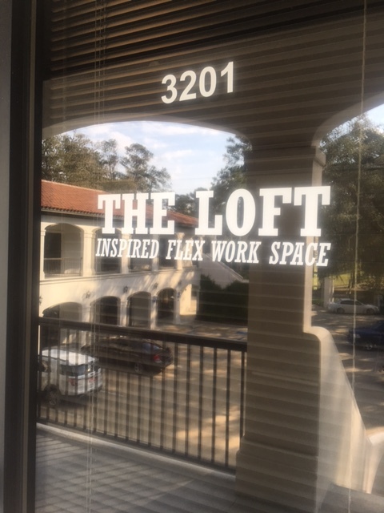

Introducing “The Loft” – Inspired Flex Work Space. A new concept at 5500 Frederica Road offering co-working office space designed to be a productive, inspiring, collaborative and energizing environment for the members. With many membership options to provide clients with office solutions to fit their needs, budget and growth plans. Call Stephen Williams at 912-434-6535 for information.

**New Year – New Spaces**

**507 Ocean Boulevard**

**2nd Floor – North Wing**

American Work was one of the original tenants at 507 Ocean Boulevard when **Lucas** Properties acquired the property. When American Work’s corporate office decided to relocate the St. Simons division to another part of the state in the fall of 2016, we decided to renovate their space and create six individual Executive Suites.

Through a tropical storm, a hurricane and the holidays – the project was completed on time. Nash Contractors did a great job transforming the space with new floors, new paint and new light fixtures.

We are now fully leased and proud to welcome our new tenants. Stop by and say hello to Rachel Berg from LifeStyle Sandbox, LLC, - Anthony King from Nibble Nation, Jim Kaminer, Attorney at Law, Donna Waters from Healing Waters Wellness and Massage and Carla Emmons from Emmons Realty.

**If you have any questions or concerns, please do not hesitate to contact us. We are available to you at 301 Sea Island Road, Suite 6, or you may reach us at 912-634-9877 during regular office hours. For emergencies after hours, please contact us at**

**912-996-0326 or** [**admin@lucasprop.com**](mailto:admin@lucasprop.com)**.**

**Web site:** [**www.lucasprop.com**](http://www.lucasprop.com)

**CELEBRATIONS!**

The Chamber of Commerce helped Rachel Berg

From Lifestyle Sandbox, Inc. host her Ribbon Cutting at

507 Ocean Boulevard and fun was had by all!

Help us say Congratulations to Rachel!

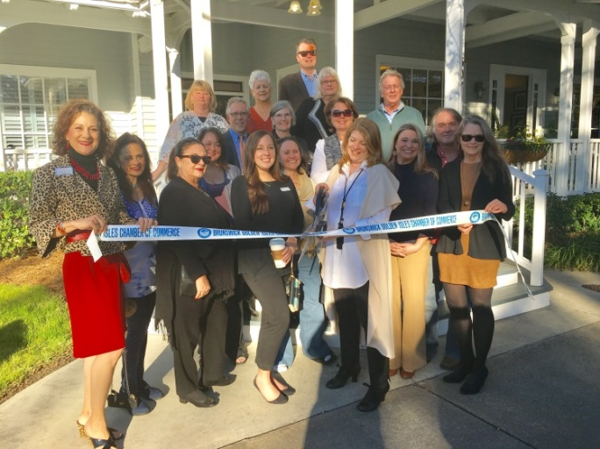

Also, Debbie Britt, Attorney at Law had her Chamber

of Commerce Ribbon Cutting Ceremony at 301 Sea Island

Road. It was a true Celebration – Welcome, Debbie!

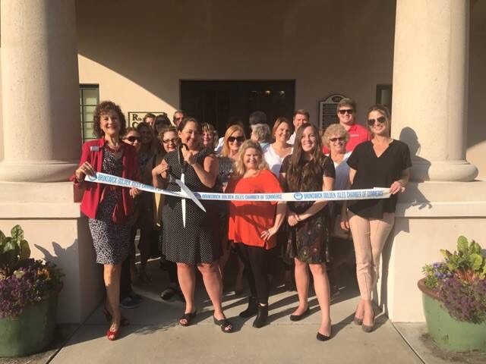

**Lucas Properties**

***Our Pledge***

**Lucas Properties strives to be your premier office leasing firm. We take pride in offering the best office leasing services in the Golden Isles.**

**Lucas Properties - Conference Rooms**

When you are meeting with clients, it is nice to have the option of using our conference areas in addition to your office space.

As tenants of **Lucas** Properties, you are able to reserve a conference room for a small fee. You can use any of the 5 rooms available at our 3 properties.

We also offer our conference rooms to guests who are not tenants. This is a great option for anyone looking for a space to meet with clients or visitors.

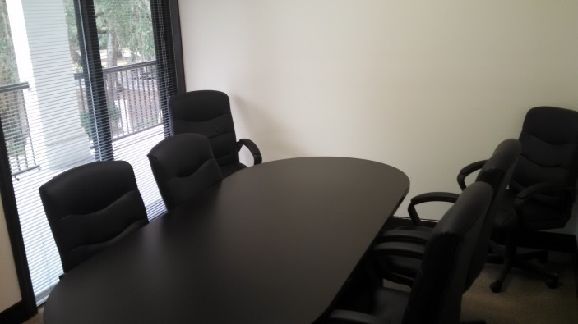

**5500 Frederica Road**

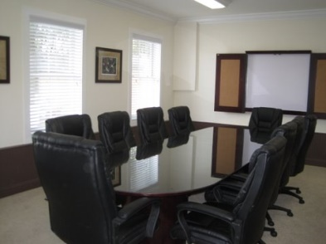

**507 Ocean Boulevard**

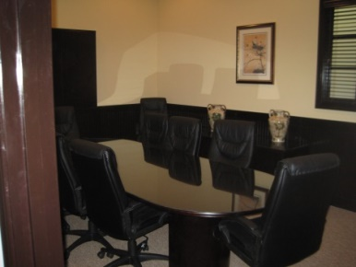

**301 SEA ISLAND ROAD**

**Conference Room Rental Rates**

507 Ocean Blvd. $40 tenant / $100 guest

301 Sea Island Rd. Small: $30 tenant / $75 guest

301 Sea Island Rd. Large: $40 tenant / $100 guest

5500 Frederica Rd. Both: $40 tenant / $75 guest