***Life at Lucas Properties***

***Summer - 2018***

**“In The Spotlight”**



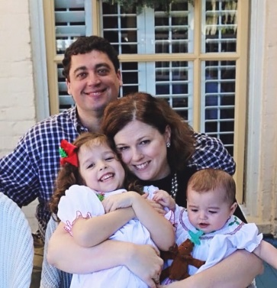

**Our featured tenants for this issue of Life at Lucas Properties are Murray Nellis Law Group and Abiding Love Adoption Agency at 5500 Frederica Road, Suite 1201 on St. Simons Island.**

**Murray Nellis Law Firm, owned and operated by Gil and Carrie Nellis, is a boutique law firm that specializes in Adoption Law, Estate Planning, Probate, Veterans Law, Tax Law, Trust Law, Asset Protection Law and Charity Law.**

**Abiding Love Adoption Agency was established in 2016 by Carrie Nellis. They are an Open Adoption Agency that serve Birthparents and Adoptive Parents with the help of Advocates, other Agencies, and Adoption Attorneys.**

**We at Lucas Properties enjoy witnessing the growth Murray Nellis Law Firm has had since occupying their first office with Lucas Properties at 301 Sea Island Road. They then moved to two adjoining executive suites at 5500 Frederica Road and eventually moved upstairs in that same building and customized their own build to suit space. That office suite houses both firms now and was expanded in 2016 to accommodate the two growing businesses. We wish them both continued success!**

[**www.murraynellislawgroup.com**](http://www.murraynellislawgroup.com)

[**www.abidingloveadopt.com**](http://www.abidingloveadopt.com)

**Art’s Reflections**

**“Chilling Out”**

**By Art Lucas**

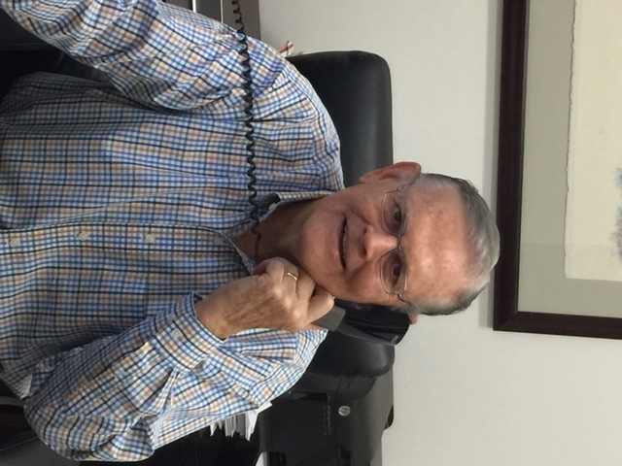 **I have just returned from a trip to France (it was exciting/fun to be in Paris when the French won the World Cup). The trip abroad for 9 days was strictly a planned vacation. That means I planned to limit my email responses, calls to the office and worries about “balls in the air”. I wanted to follow the advice from a management consultant who spoke at a conference I attended a number of years ago. He said, “Wherever you are, be there”. Enjoy the wonders of your new environment and quit stressing over events back home – or back at the office. For the limited amount of time you have on your vacation, be on vacation!**

**I find it very difficult to follow that sage advice. In this day and age, we have our IPhones and other communication devices attached to our bodies. We are clicks away from updates, returning messages and weighing in with strong opinions. Phone calls with our hand held devices are just as simple as dialing someone in Brunswick. You don’t need country codes or operators – just simply dial the local area code and phone number and voila – the phone is answered and it sounds like next door.**

**In spite of my curiosity of what’s happening back at the office, I did manage to limit my communications to less than 1 per day. I really tried to focus on my vacation, and being in France made the job a lot easier. Now that I have returned, I can “be there” on St. Simons Island. It is a great place to be!**

**Lucas Properties Expands to Darien Market with the Oaks on the River Project**

**BEFORE**

**Before**

[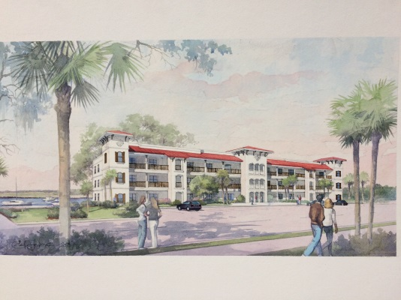](http://www.google.com/url?sa=i&rct=j&q=&esrc=s&source=images&cd=&cad=rja&uact=8&ved=2ahUKEwjEi5CT-uLbAhXFtVkKHXXoA1gQjRx6BAgBEAU&url=http://travellogs.us/2010%20Logs/Georgia%202010/10-55%20Darien%20Georgia/10-55cc%20Darien%20River.htm&psig=AOvVaw1b92voNDiMIT4iEUOeo5Wt&ust=1529608576196808)

**The Darien Waterfront will be receiving a new look in the coming months. The area east of the Hwy. 17 Bridge (previously the McIntosh County Industrial Development Authority Office and the current Golden Isles Seafood processing facility) will be developed as Oaks on the River.**

**Phase I of the Oaks on the River project will include replacing the Development Authority building (on the west side of the property) with a 4,000 plus sq. ft. restaurant with gorgeous river views along with the construction of a multi-story, 12 unit riverfront condominium complex on the east side of the property. We anticipate construction of Phase I to begin in the fall of 2018.**

**Phase II of the Oaks on the River project will feature an upscale boutique hotel with approximately 45 - 50 rooms, 2,000 sq. ft. of retail space and a marina.**

**The Oaks on the River project is sure to be a game changer for the City of Darien and for McIntosh County as a whole. We have received overwhelming support by the Darien City Council and the McIntosh County Development Authority. Local residents and business owners alike have sent us multitudes of well wishes and expressions of excitement about the employment opportunities and number of customers who will be brought to the area with the addition of the Oaks on the River complex to the area. We will continue to keep you posted on the progress!**

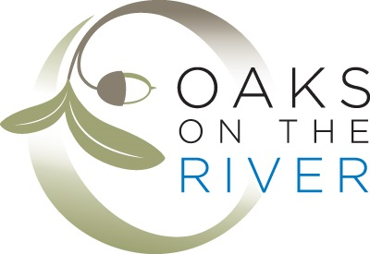

**Welcome New Lucas Properties Tenants**

**301 Sea Island Road**

King Austell Logistics-Virtual Tenant

**507 Ocean Boulevard**

Mallard Management Services-Suite 303

Pate & Johnson-Suite 204

**5500 Frederica Road**

Southport Capital Risk Management-Suite 1209

Kevin Gough Firm, LLC-Suite 1217

The Ramay Law Firm-Suite 1211

**Don’t Forget Our Conference Rooms!**

**Call for Pricing and Availability**

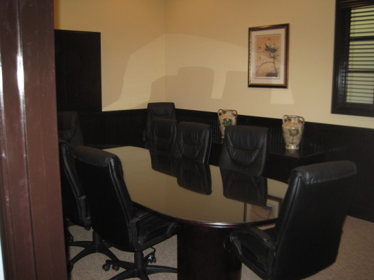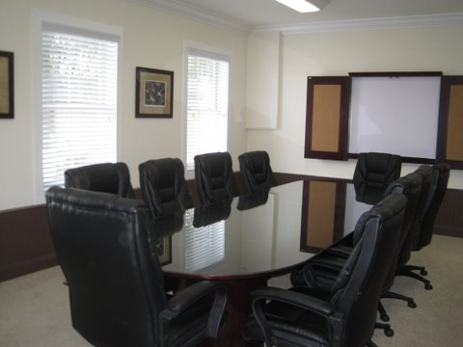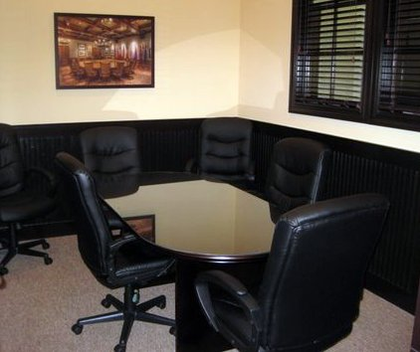

**Lucas Properties - Virtual Office Options**

**The Address Package offers the prestigious Sea Island Road address with daily mail package receiving services. The Meeting Package offers access to our 5 conference rooms (in three SSI locations) up to 4 times per month included and then a discounted tenant rate after that. Contact us for more information and pricing at 912.634.9877**

**CONTACT US:**

**301 Sea Island Road, Suite 6**

**912-634-9877**

**Monday thru Thursday: 8:00 am – 4:00 pm**

**Friday 8:00: am – 3:00 pm**

**For Emergencies After Hours - 912-996-0326 or** [**admin@lucasprop.com**](mailto:admin@lucasprop.com)

**Web site:** [**www.lucasprop.com**](http://www.lucasprop.com)

***Our Pledge***

**Lucas Properties strives to be your premier office leasing firm. We take pride in offering the best office leasing services in the Golden Isles.**