Life at Lucas Properties
Winter - 2018
“In The Spotlight”
Carol Cave
SWBC Mortgage Corporation

Meet Carol Cave with SWBC Mortgage Corporation. Carol has been a tenant with Lucas Properties at 507 Ocean Boulevard for multiple years.
Carol says “My goal is to help my clients succeed at one of the most important decisions they can make in their life. Meeting the goal of home ownership is not just a sense of accomplishment, but can also be a great investment. I am committed to making this experience for my clients both positive and memorable”.
Carol will walk buyers through the mortgage steps and help them enjoy the process of buying their home. Whether a first time homebuyer or simply trying to increase a portfolio with real estate investments, Carol leads her clients through the process.
You Can Reach Carol at:
Office 912-268-4303 Cell: 912-399-0982

.

Welcome New Lucas Properties Tenants

507 Ocean Boulevard
Signal Box-Suite 204
Violet Harrigan/Massage Therapist-
Suite 214
Insurance Partners Consortium, Inc.–Suite 302
Coldwell Banker (Expanding)-Suite 201

5500 Frederica Road
Cadence Capital Solutions-Suite 1213
Emerald Isle Counseling-Suite 1221
Annette Bacola–Suite 1207
Kevin Mitchell and Assoc.–Suite 2207

301 Sea Island Road
Finch McCranie-Suite 8
Banker Real Estate (Expanding)-
291 Sea Island Road
Roberts Civil Engineering (Expanding)-Suite 12
Ramsey McHale-Suite15
CIBC Atlantic Trust Investment Advisors
-Suite 16
Insurance Office of America-Suite 19
Morgan Stanley – Suites 21 through 28

Art’s Reflections

“How to Survive / Thrive the Economic Swings”
By Art Lucas

I have spent my 40 plus year business career in two industries that certainly feel the effects of the national economy (Recruiting/Executive Search and now Commercial Real Estate). I have seen many ups and downs, at least five recessions at last count. I have found that the good times can be almost as challenging as the down turns. Each period has opportunities and negatives, and I’ve tried to develop a game plan that dealt with both.
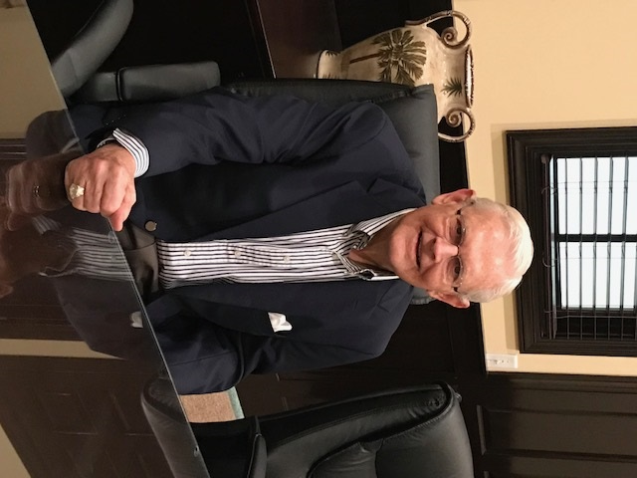
We are now experiencing a healthy economy. In most cases our tenants are doing well and a growing number are seeking more office space to grow their firms. Also, rents are rising as the Law of Supply and Demand takes effect. That is good news for Lucas Properties, but “good time” challenges abound. Our vendors have begun raising prices, which makes our cost of operation increase. We also tend to over expand in the up periods as we think the positive economy will last forever. In addition, for companies adding new staff, it can become very challenging. Talented people are in great demand now.

I’ve always preferred the up cycles over the down, but have found recessions as a time to strengthen the business. Downtimes make us focus on costs and what is really important. It is a good time to negotiate contracts with suppliers, to purchase new equipment, or in my case, real estate. It’s also a perfect time to hire excellent talent as more good people are available.

Finally, I would sum up by saying that in good times you harvest and save and in bad times you build. Both periods have advantages for smart organizations.

Good Things Come To Those Who Wait

It became clear early on that the 301 Sea Island Road location would be very desirable for those in need of office space on St. Simons Island. We immediately became fully leased at this location with a considerable waiting list.
BEFORE

With the 301 Sea Island Road building in such high demand it made sense to add additional space to the property. That process began back in 2014.
Before

As many of you know, we faced a few obstacles along the way. However, with the help of many community supporters, loyal vendors and friends of the firm, we can finally say that our goal has been accomplished.
We now have added approximately 3,600 square feet to 301 Sea Island Road and are proud to welcome our new tenants. Morgan Stanley, CIBC Atlantic Trust Investment Advisors, Insurance Offices of America, Tadd Wessel and Ramsey McHale have all joined the Lucas Properties family in our new addition. North Sea Global also moved from the original section to the new section of the building. We also were able to renovate a portion of the existing space to allow for the expansion of two of our original tenants, Roberts Civil Engineering and Banker Real Estate.

Good things do come to those who wait and persevere!
_______________________________________
Lucas Properties - Virtual Offices
As demonstrated by the success of one of our virtual tenants, Rachel Hicks with Slightly OCD Cleaning Service (912-304-3077), Virtual Office options are a unique way to “bridge the gap” between a home office and leasing a physical office space.
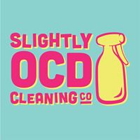
The Address Package offers the prestigious Sea Island Road address with daily mail package receiving services. The Meeting Package offers access to our 5 conference rooms (in three SSI locations) up to 4 times per month included and then a discounted tenant rate after that.

Contact us for more information and pricing at 912.634.9877
Don’t Forget Our Conference Rooms!

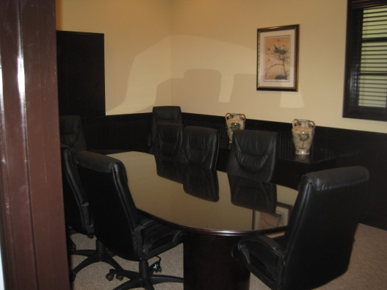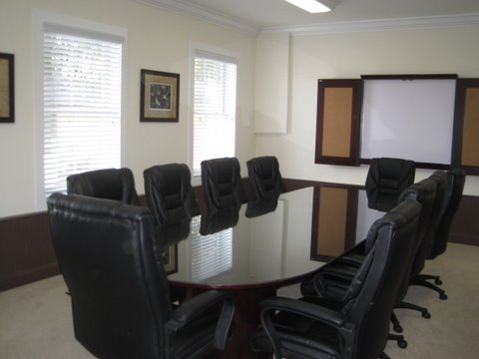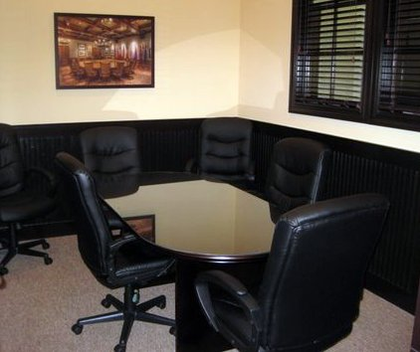

Conference Room Rental Rates
507 Ocean Blvd. $40 tenant / $100 guest
301 Sea Island Rd. Small: $30 tenant / $75 guest
301 Sea Island Rd. Large: $40 tenant / $100 guest
5500 Frederica Rd. Both: $40 tenant / $75 guest

CONTACT US:
If you have any questions or concerns, please do not hesitate to contact us. We are available to you at 301 Sea Island Road, Suite 6, or you may reach us at 912-634-9877 during regular office hours. For emergencies after hours, please contact us at 912-996-0326 or admin@lucasprop.com.
Web site: www.lucasprop.com

Lucas Properties
Our Pledge
Lucas Properties strives to be your premier office leasing firm. We take pride in offering the best office leasing services in the
Golden Isles.

