5500 Frederica Road
St. Simons Island, GA 31522

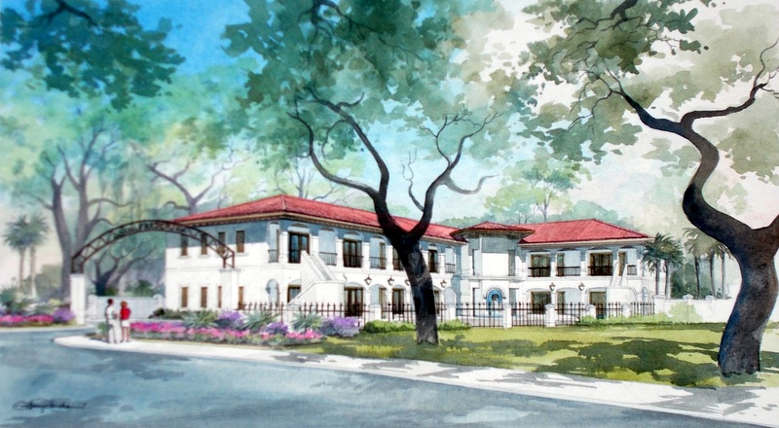

EXECUTIVE SUITES
CURRENT PROMOTION
1 Month Free with a 1 Year Lease
2 Months Free with a 2 Year Lease
3 Months Free with a 3 Year Lease

- Includes Reception Area, Conference Room and Breakroom

- Access to Conference Rooms at other Lucas buildings with Video Conferencing and Concierge Services available

- Ample parking

- Local owner with property management team that can rapidly respond to tenant requests

- Best product and service in Golden Isles area

LUCAS PROPERTIES, LLC

BEST OF CLASS OFFICE & RETAIL SPACE . EXECUTIVE SUITES . VIRTUAL OFFICES
301 Sea Island Road, Suite 6, Saint Simons Island, GA 31522
T: (912) 634-9877 F: (912) 634-9875

www.lucasprop.com

